1. Sales Analysis Dashboard: Create a dashboard that shows sales trends over time, by region, and by product category. Use different visualizations to highlight key metrics, such as sales growth rates, top-selling products, and regional sales comparisons.

**Sales growth rates:**

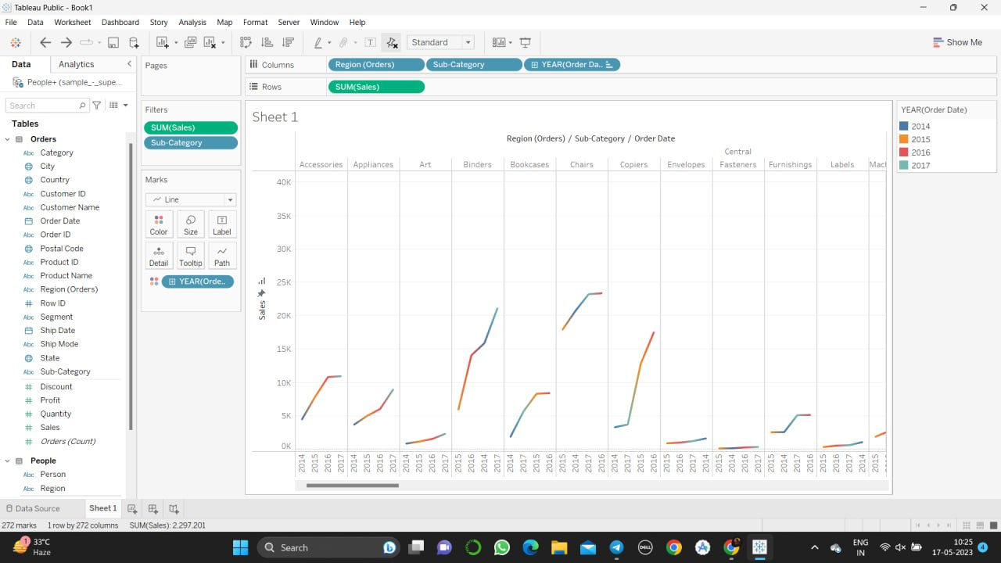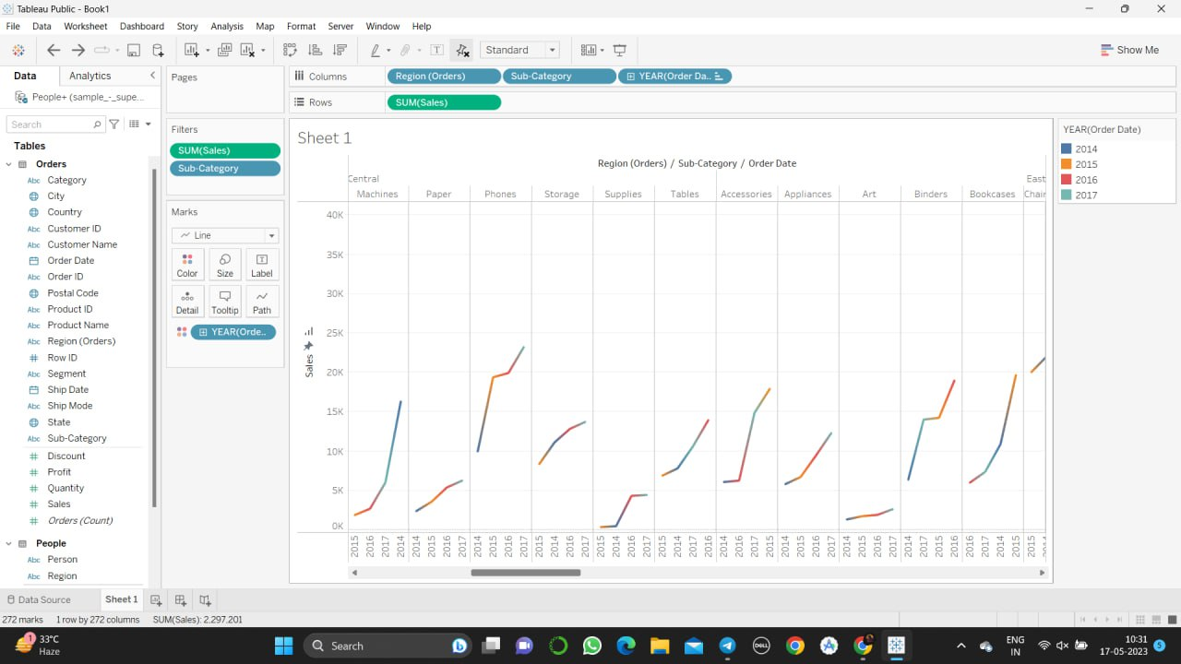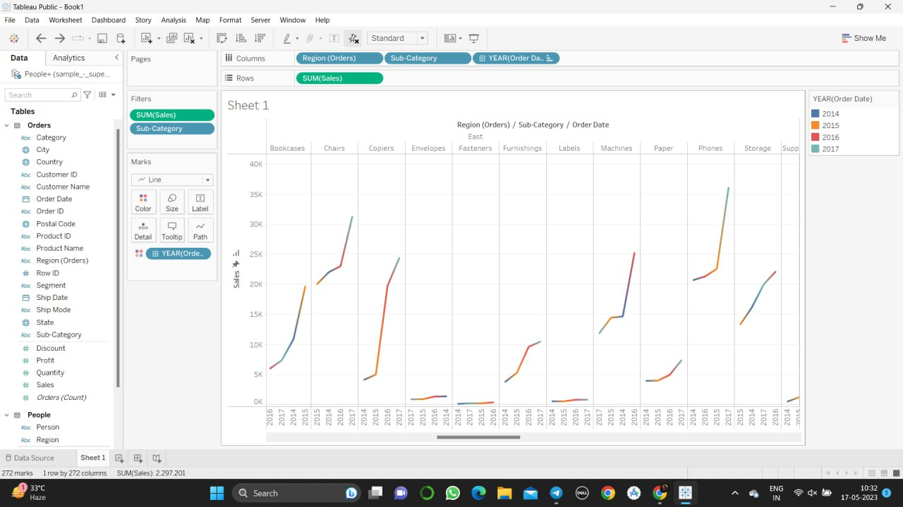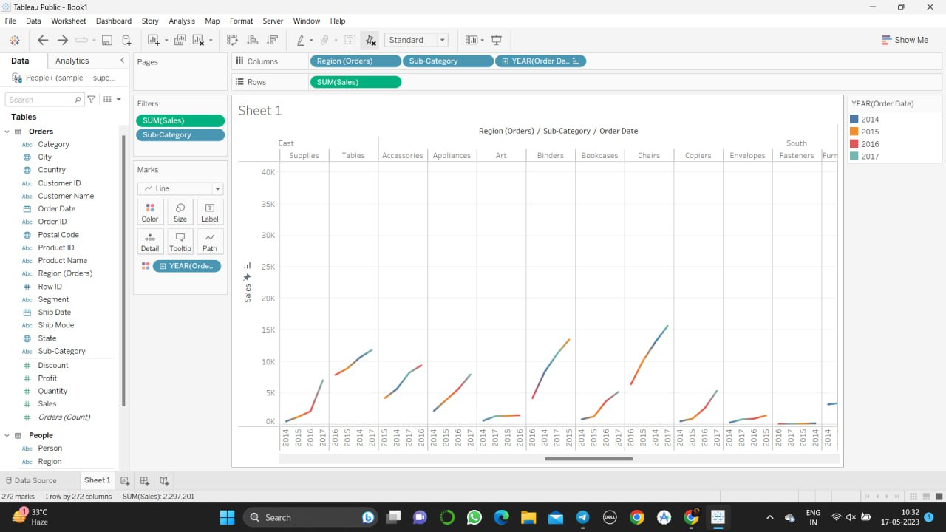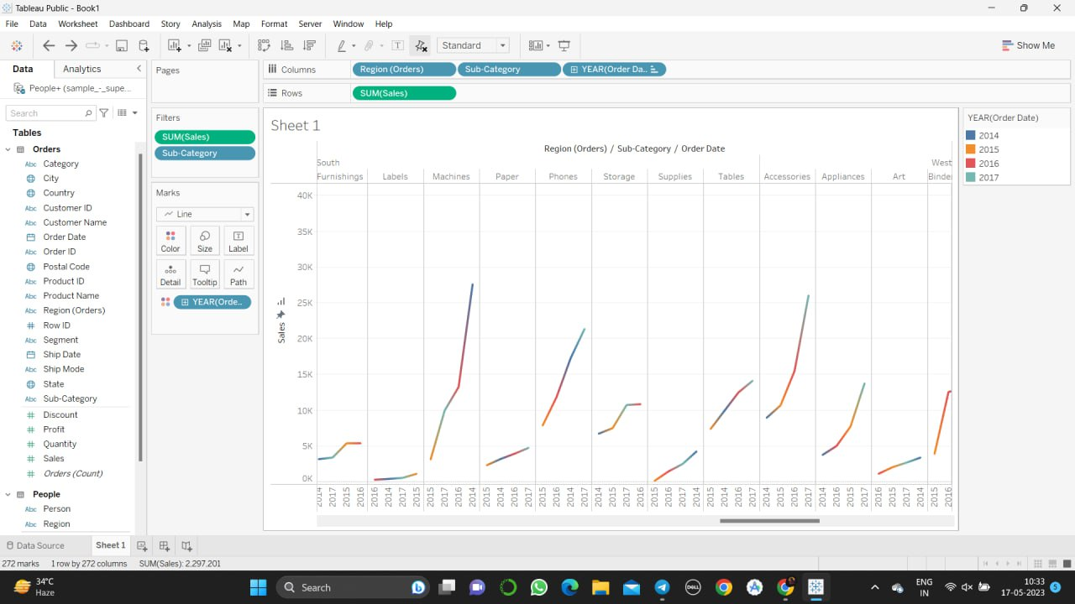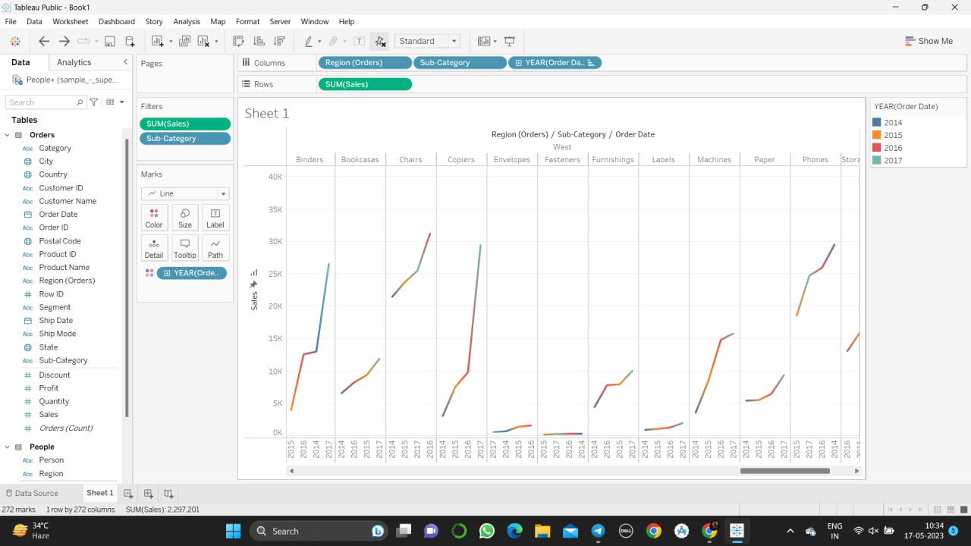

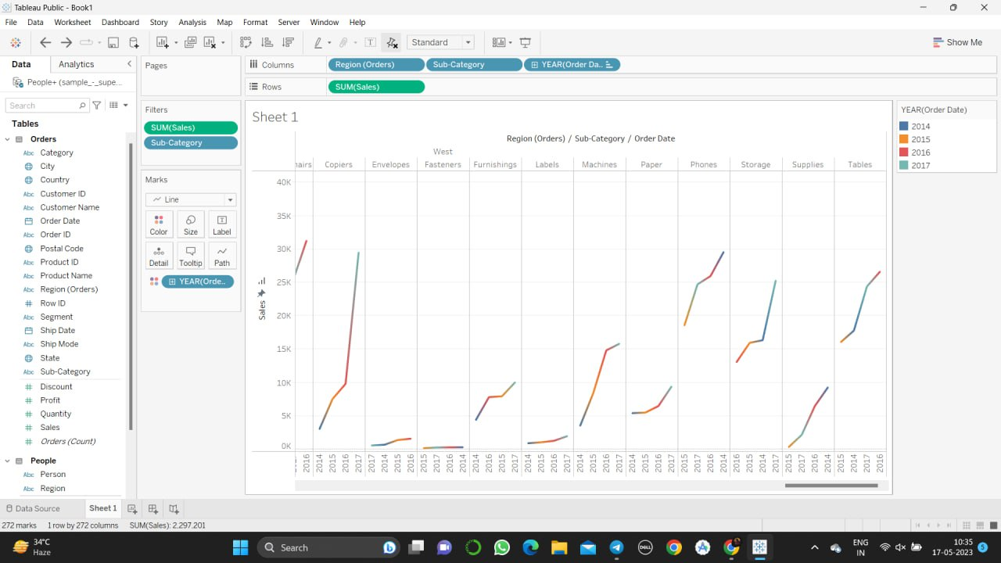

**Top-selling products:**

**Regional sales comparisons:**

